Step1

Connect to database example mysql

2. Refer to this pane and custom sql option at the bottom

3. Click on custom sql

4. write a query and run

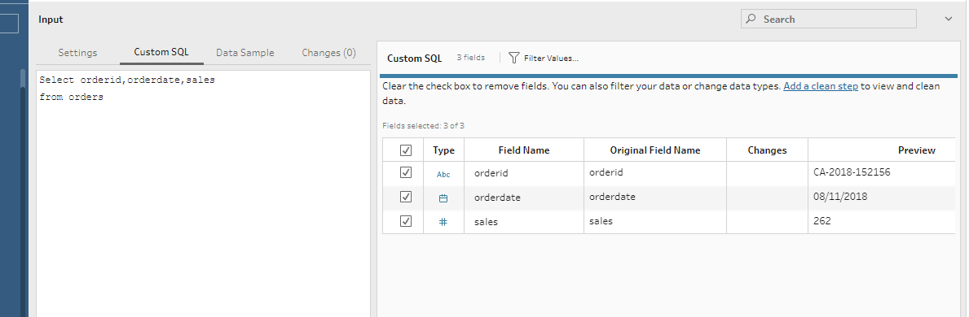

5. Change setting / Data sample

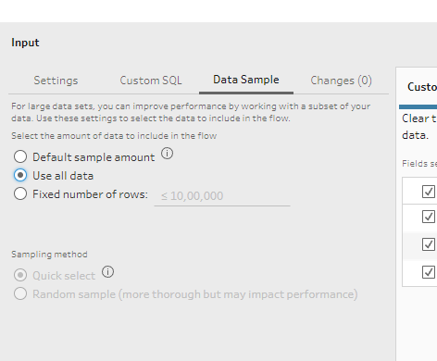

6. Add a clean/view step to see the data

7. Further u can join / union other tables

